2017 REGIONAL CONVOCATION
OF THE CHRISTIAN CHURCH (Disciples of Christ) IN AL-NW FL
THREE-DAY ASSEMBLY
FRIDAY, JUNE 23 – SUNDAY JUNE 25, 2017
NEW VISION CHRISTIAN CHURCH (Disciples of Christ) BIRMINGHAM, ALABAMA

REGISTRATION, MEAL RESERVATION, AND T-SHIRT ORDER FORM

REGISTRATION FEES:

Registration postmarked on or before May 23, 2017:

___ADULT $20.00 per person
___YOUTH (Ages 6-18) $15.00 per person
___T-SHIRT (Circle Size: S, M, L, XL, 2X, 3X, 4X) $10.00 per shirt
___ T-SHIRT OPTION 1 (Chalice)
___ T-SHIRT OPTION 2 (Armor of God)
(See back page for options)

Registration postmarked after May 23, 2017:

___ADULT $25.00 per person
___YOUTH (Ages 6-18) $15.00 per person

NOTE: T-shirt orders will not be accepted after May 23, 2017.

AMOUNT ENCLOSED: $______________

MAKE CHECKS PAYABLE TO: Convocation of the Christian Church in AL-NW FL

MAIL REGISTRATION FORMS, CHECKS, AND CHALLENGE GOAL TO:
MALDONIA JACKSON – TREASURER
191 JACKSON ROAD
HAYNEVILLE, ALABAMA 36040

PLEASE COMPLETE THE FOLLOWING INFORMATION FOR EACH PERSON:

Name_____________________________________________________________________
Address___________________________________________________________________
City__________________________________ State_____________ Zip______________
Congregation_______________________________________________________________

IMPORTANT NOTE:
THIS FORM MUST BE COMPLETED FOR EACH PERSON REGISTERING
AND/OR ORDERING A T-SHIRT.

T-SHIRT OPTIONS

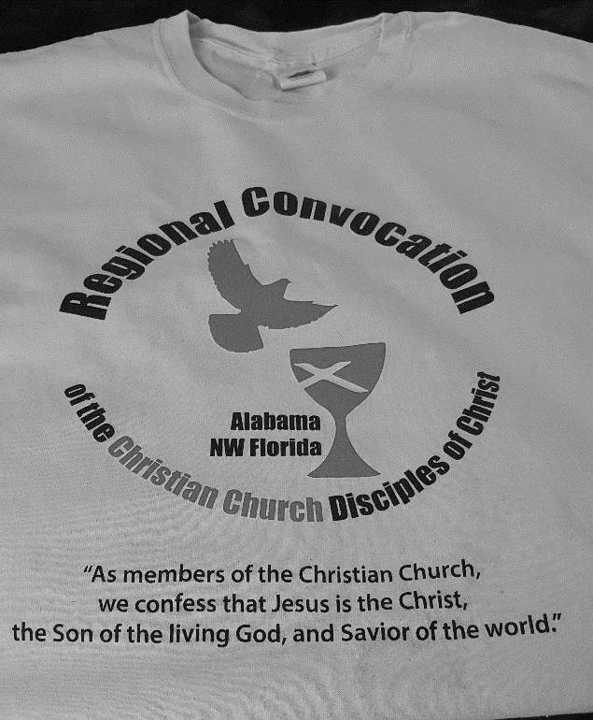
CHALICE
OPTION 1
T-Shirt from 2016

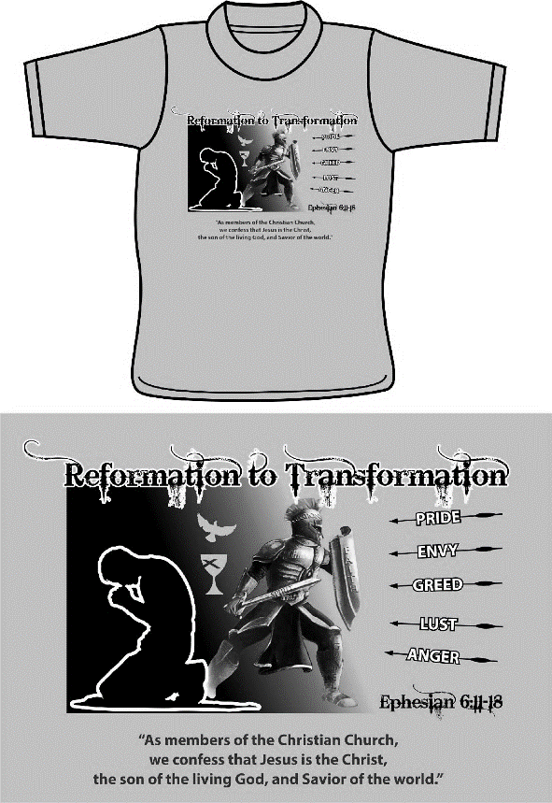
ARMOR OF GOD
OPTION 2
New T-Shirt

NOTE: THE DEADLINE TO ORDER T-SHIRTS IS MAY 23, 2017

